/* july 22*/

use july1;

alter table person add column city varchar(50);

alter table person modify column city varchar(50) default 'satara';

update person set city='satarea' where id=1;

select * from person;

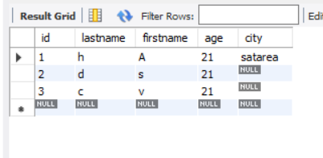

/*Question 1 auto increment*/

create table person3(pid int not null auto_increment,lastname varchar(40) not null,firstname varchar(40),age int,primary key(pid));

insert into person3(lastname,firstname,age) values('h','a',23);

insert into person3(lastname,firstname,age) values('c','v',23);

select * from person3;

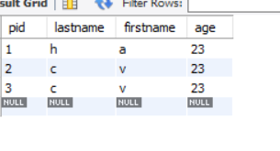

/* Question 2*/

create table emp(eno int primary key,ename varchar(50),designation varchar(50),salary float,date_join date);

insert into emp values(1,'Mr.Advait','assistant',54000,'2020-04-20');

insert into emp values(2,'Mr.Raghav','manager',94000,'2020-04-20');

alter table emp add column email varchar(30);

update emp set email='adityahublikar11@gmail.com' where eno=1;

update emp set email='ragav11@gmail.com' where eno=2;

alter table emp modify column email varchar(40) default 'xyz@gmail.com';

update emp set salary=salary+salary*0.05 ;

UPDATE EMP SET DESIGNATION='SR.MANAGER' WHERE ENAME='MR.RAGHAV';

UPDATE EMP SET DESIGNATION='SR.ASSISTANT' WHERE DESIGNATION='ASSISTANT';

select * from emp;

ALTER TABLE EMP MODIFY COLUMN CITY VARCHAR(40) DEFAULT 'PUNE';

UPDATE EMP SET CITY='PUNE';

UPDATE EMP SET CITY='MUMBAI' WHERE ENAME='MR.ADVAIT';

INSERT INTO EMP VALUES(3,'MR.KARAN','CEO',100000,'2020-03-23','XYZ@GMAIL.COM','PUNE');

UPDATE EMP SET SALARY=SALARY-SALARY*0.05 WHERE DESIGNATION='CEO';

ALTER TABLE EMP ADD COLUMN PHNO BIGINT NOT NULL;

INSERT INTO EMP VALUES(4,'MR.ROY','CLERK',70000,'2019-06-05','MR.ROY1@GAMIL.COM','MUMBAI',9765447473);

UPDATE EMP SET DATE_JOIN='2023-09-21' WHERE ENAME='MR.ROY'AND CITY='MUMBAI';

ALTER TABLE EMP CHANGE DATE_JOIN DATE_NEW DATE NOT NULL;

DESC EMP;

/*SELECT QUESTION*/

SELECT * FROM EMP WHERE ENAME='MR.ROY';

SELECT SALARY ,DESIGNATION FROM EMP WHERE ENO=4;

SELECT * FROM EMP WHERE DESIGNATION='CEO';

SELECT DATE_NEW FROM EMP WHERE ENO=1;

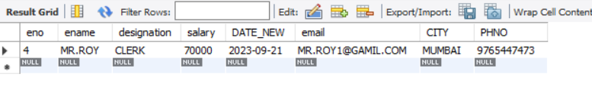

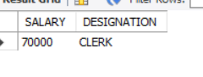

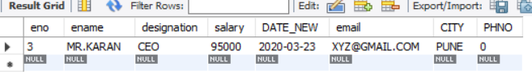



/*RELATIONAL OPERATOR*/

SELECT * FROM EMP WHERE SALARY>=50000;

SELECT * FROM EMP WHERE SALARY<=50000;

UPDATE EMP SET SALARY=50000 WHERE ENAME='MR.ROY';

SELECT * FROM EMP WHERE SALARY=50000;

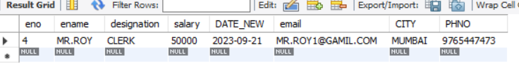

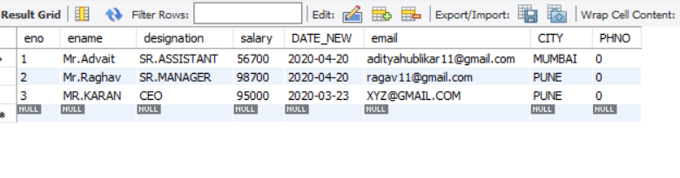

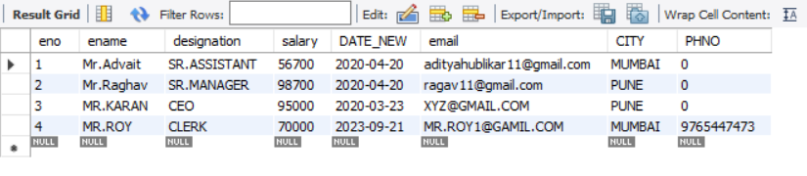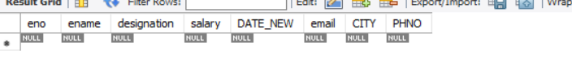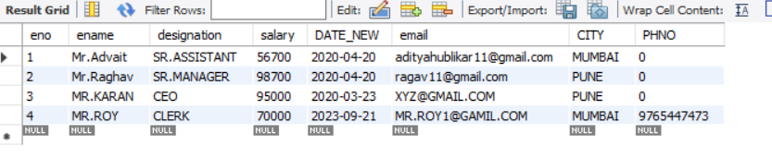

/*logical operator*/

UPDATE EMP SET SALARY=10000000 WHERE DESIGNATION='CEO';

SELECT * FROM EMP WHERE DESIGNATION='CEO' AND SALARY>=100000;

SELECT * FROM EMP WHERE DESIGNATION='CEO' OR SALARY>=100000;

